**Use Case Diagram:**

**Title:** Academic Interactive-Health Website

**Description:** Students will learn and be encouraged to partake in making healthy lifestyle choices through the design of a fun and interactive website. Parents/Guardians,Teachers and School Officials will be able to track and monitor their student’s progress as well.

**Actors:** Students, Parents/Guardians, and Teachers and School officials.

**Triggers:** Student login and plays interactive games on website. Parents/Guardians, Teachers and School Officials login on website to view and monitor child’s progress.

**Main Course:**

**Students:**

1. Student logs into the website.

2. Student takes health quiz to assess knowledge and retention of information.

3. Student plays interactive health games individually and/or against other students.

4. Student’s progress is tracked by score keeper.

**Parents/Guardians:**

1. Parents/Guardians log into website.

2. Click on website to view their child’s progress on the scoreboard.

3. Parents click on discussion board to upload their thoughts and comments.

4. Parents click on make a donation.

5. Site transitions to donation web service.

6. Parent enters card information and amount they are donating.

7. Parent submits payment and receives a confirmation receipt.

**Teachers:**

1. Teachers log into website.

2. Teacher selects the child’s profile that they wish to comment on.

3. Teacher leaves comment under the child’s profile that will only be visible to that child’s parent or guardian.

**School officials and administrators:**

1. School officials/administrators log into website

2. School officials/administrators can view all records of students and classes

**Alternative Course(s):** User isn’t registered for site.

**Exception(s):** Site crashes.

**Pre-Condition(s):** All users must register to use site.

**Students:**

Must be a student enrolled at a participating school.

Must have parental permission to use site.

**Parents:**

Must be parent of a student at a participating school that is registered to use the site with a verified classroom id to a specific school.

**Teachers:**

Must be a teacher at a participating school and the teacher of the children’s scores that you are able to see.

**Post-condition(s):**

Teachers, School Officials and Parents receive notifications about their student’s progress.

Students learn healthy lifestyle choices.

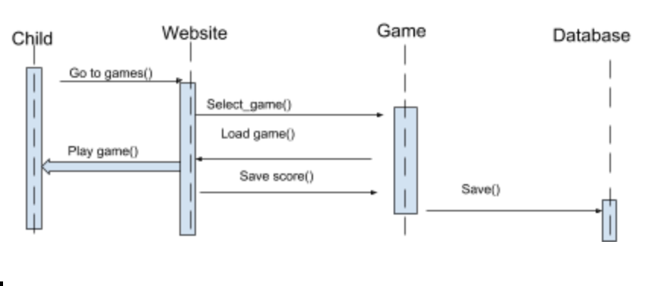

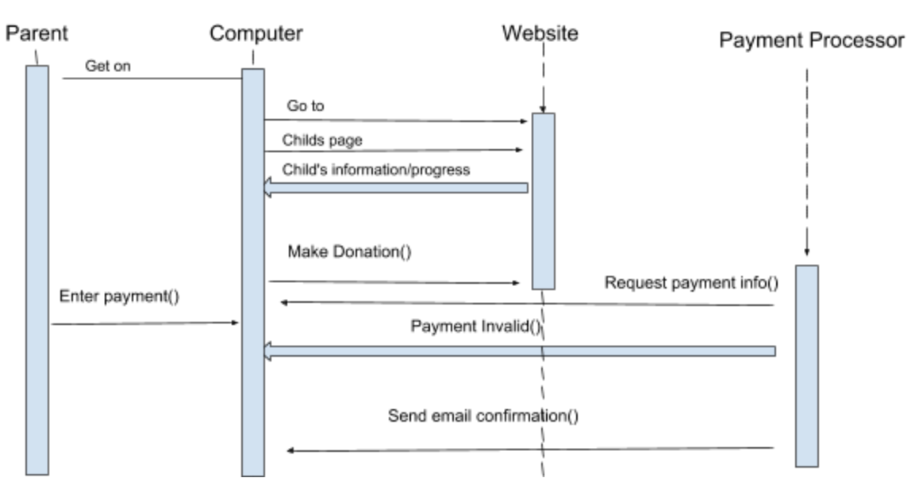

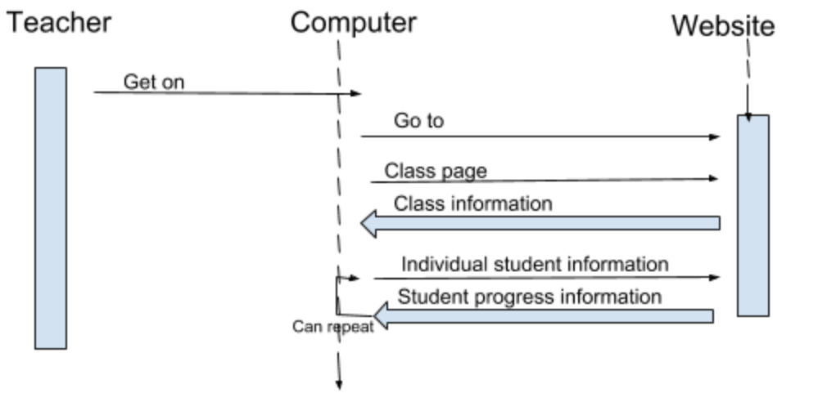

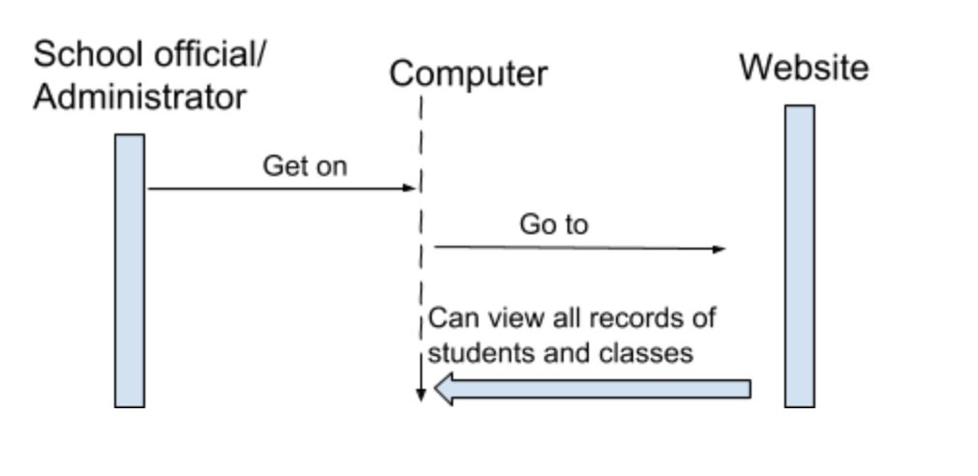

Includes leaderboard info which will be displayed to the main page. User will login/ register to gain access to account (student logins/registration must be affiliated with a pre existing parent login). User information is matched with a database for validation and access to the create or login to a user’s profile. If information is incorrect re-prompt the user to enter again until valid credentials are entered. Limit user to 5 login attempts before locking account temporarily. (possibly add extra screen to deter bots from brute forcing user passwords.) All users will have access to edit/ save profile. Only parents and teachers may write comments.

Only **Student** logins, when matched to the database will have access to the game. Game scores are sent directly to leaderboards and updated. Leaderboard scores will be accessible by any login and available on the website. Students must also be tied to a parents information to validate student accounts as well as with a class id that is linked to the teacher.

**Teacher** logins will have access to student list via database and will be able to tag/ apply notes to students through the website each teacher will have a class id to easily access anyone registered with the proper class id. These notes will only be visible to parents logins.

**Parent** Login/registration will be met with an id for a link to the correct classroom before registering their child. Upon login parents will have access to read student notes left by teachers. Any parent may also make a donation via donation link on site. Site will use pre-existing card information, but will always validate first. If a payment option is invalid then reprompt for valid information. Otherwise move on to accept payment and pass along email validation

